The Raleigh protector 100 shackle lock comes complete with a carrying bracket and handy flexible cable. Made from 12mm hardened steel with a double locking mechanism for maximum security, the cylinder is both pick and drill resistant. Fantastic pull resistance, 115mm x 229mm

The Raleigh protector 200 shackle lock comes complete with a carrying bracket and handy flexible cable. Made from 12mm hardened steel with a double locking mechanism for maximum security, the cylinder is both pick and drill resistant. Fantastic pull resistance, 115mm x 292mm

Magnum 3101 ulock
- Lk3000 U-Lock Massive Hardened Ultra Steel Shackle Provides Maximum Cut Resistance.
- Double Bolt Locking Mechanism Deliver Up To 10 Tons Pull Strength.
- All Tube Multi-Position Quick Release Mounting Bracket.
- 5 Keys

Pitbull 8002
14mm massive ultra hardened steel shackle provides maximum cut resistance Unique OnGuard cylinder offers optimum resistance against physical attack and picking Reinforced sleeve over crossbar and cylinder for additional security Triple layer steel crossbar Quattro bolt locking mechanism with dual lockdown protection pins the steel shackle at both ends creating a double lock that can withstand up to 8 tons of pull force while the M-cylinder provides an added level of security and ease of use Rotating dust cover protects cylinder Protective vinyl coating on shackle Double rubber coating on crossbar Anti-theft protection plan 14mm U-Lock 4.5in. x 11.5in.
- Brand: ONGUARD
- 14mm massive ultra hardened steel shackle provides maximum cut resistance
- Unique OnGuard cylinder offers optimum resistance against physical attack and picking
- Reinforced sleeve over crossbar and cylinder for additional security
- Triple layer steel crossbar
- Rotating dust cover protects cylinder
- Protective vinyl coating on shackle
- Double rubber coating on crossbar
- Anti-theft protection plan. . 14mm U-Lock 4.5in. x 11.5in.. .

Squire Zenith CN 6/900 Chain - With LED
- Chain 900mm Long
- LED included
- 6mm Square linked hardened steel
- Chain lock
Pitbull 5002
The On Guard PitBull U-Locks feature 8.4 Tons of pull strength plus higher quality lock cores.
- Keyed locks include five European-style keys, (1 lighted), all tube QR mounting bracket
- Pitbull has 8.4 Tons pull strength plus higher quality lock cores
- Unique cylinder offers optimum resistance to picking and reinforced sleeve over crossbar for additional security
- 13mm ultra-hardened steel shackle provides maximum cut resistance
- $2,251 anti-theft protection offer
Item Specifications
Lock Size | 4.5" x 11.5"
Bracket Incuded | yes
Pitbull 8003
Dimensions:
4,53" x 9.06" / 115mm x 230mm

Specs:
1. The Quattro Bolt Locking Mechanism Provides Unequaled Strength And Maximum Pull Resistance By Locking The Cross Bar To The Shackle On 4 Sides.
2. The New User Friendly, Pick, Pull And Drill Resistant OnGuard Z-key Cylinder Featuring Bumpblok, Offers Optimum Deterrent Against Physical Attack.
3. Includes 5 Laser Cut Keys (1 Micro-Light And 4 Extra Grip Keys) Micro-Light Key Projects A Bright White Beam.
4. All Tube Quick Release Multi-Position Mountain Bracket.

Additional Features:
1. Massive 14mm (0.55") Ultra Hardened Steel Shackle Provides Maximum Cut Resistance.
2. Double Rubber Coating On Crossbar.
3. Ultra-Hardened Reinforced Crossbar.
4. Anti-Rattle Bumpers.

Magnum 3000 U-Lock
Product Number: 5019-938
Made in China
Weight: 2.16kg
Give bike thieves some serious pause for thought with this big, tough lock. It’s Magnum’s highest rated U-lock, and boasts a hardened ultra-steel shackle.
- Shackle is 110 x 260mm and 16mm thick.
- Rotating dust cover keeps grit out of the mechanism.
- Pick and drill resistant lock mechanism.
- Five keys included.
- Rated 10/10 on Magnum’s security scale.
- Oxford hoop
- 600mm x 12mm. Weight only 114g. Supplied with 2 keys^An easy to use, key operated hardened steel cable bike lock^sheethed in vinyl to prevent damage to bicycle paintwork

3023,3024,3025 3017
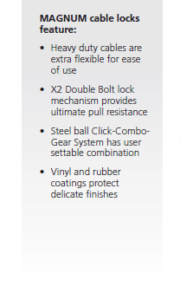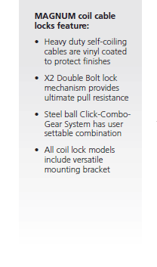

3000,3101 Raleigh force 100
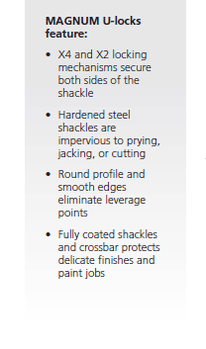
- 9.5mm hardened steel links provide maximum resistance
- Double fabric sleeve prevents scratching andeasy compact coiling
- High security cylinder
- Double locking mechanism

Oxford HD Chain Lock Heavy Duty Chain and Padlock. Hardened 1.4m x 10mm square link chain. Tough double locking padlock with hardened steel shackle which doubles as a disc lock. Key dust cover OF157

Oxford Chain Lock with Sleeve
Chain Lock with Sleeve.
Simple lock and chain to keep the bike thieves away. 36” long with a vinyl sleeve to protect paint work.
- Colour: Black
- Size: 40mm x 900mm

